Ramapo Indian Hills
GRADE 9 Summer Reading 2022

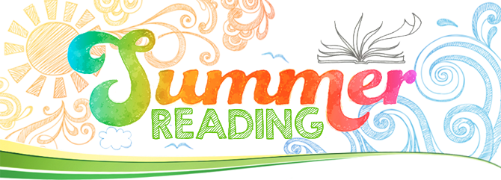

“Today a reader, tomorrow a leader.” Margaret Fuller

Reading is pleasurable and worthwhile. It offers you the opportunity to travel, to explore new places, and to experience a variety of interesting people and events all from the comfort of your own space. At the same time, reading a good book gives you a chance to practice your comprehension skills, to sharpen your reading rate, and to expand your vocabulary. Reading gives you the best of both worlds!

*All English 1 Honors students are required to read A Separate Peace by John Knowles IN ADDITION TO any text of your choice.

Please read the directions below:

- SELECT a book that you have not read before. It may be an intriguing new work of fiction, that dystopian novel your friends are talking about, or even a work of nonfiction about a subject you want to explore. Choose something that interests you! Consider consulting with your current teacher, school or town librarian, parents, and/or peers to help you with the selection process. You may also consult the ‘Book Selection Resources’ at the end of this assignment.

- ENJOY the read! You may wish (though it is not required) to take notes on the elements of narration (characters, setting, plot, conflict, themes, etc.) so that you can recall key points of your reading. You may also make notes or comments about your own personal responses, observations, or questions about what is happening in the book.

- REFLECT on your reading. Once you finish the book, write a 250-350 word typed response. (Honors students--write a response to each book, two responses in total.) Briefly explain why you chose the book and then offer some reaction to it. This might be a personal, creative, or academic response---you decide! The important thing is that your response demonstrates the thinking that you did as a result of the reading. Whatever you do, do not simply summarize the book! (*Once you arrive in class, your teacher will instruct you to submit this work through Turnitin.com, an anti-plagiarism site, so be sure your work is original. )

- SHARE with your teacher and peers. Your thoughtful response to the book and your ability to discuss it in class will be the subject of one of the first assignments of the school year. Your English teacher will provide more details during the first week of school. Just be sure to come to class with your book--or have access to it-- and bring a hard copy of your typed response on
FRIDAY, SEPTEMBER 9, 2022.

HAPPY READING!!!!

BOOK SELECTION RESOURCES

*Parents are urged to assist students in their text selections by consulting reviews at amazon.com and bn.com for additional information. Please be aware that some of the contemporary titles may depict mature and/or controversial topics. Families are encouraged to review titles carefully prior to students’ text selection in order to choose the one that is most suitable.

Suggested Titles:
(*These are merely suggestions! Feel free to choose a book that is not on the list.)

- City of Bones by Cassandra Clare
- The Orphan’s Tale: A Novel by Pam Jenoff
- The Adoration of Jenna Fox by Mary PearsonThe Hate U Give by Angie Thomas
- The Absolutely True Diary of a Part-Time Indian by Sherman Alexie
- A Long Way Gone: Memoirs of a Boy Soldier by Ishmael Beah
- The Secret Story of Sonia Rodriguez by Alan Lawrence Sitomer
- Leonardo’s Legacy: How Da Vinci Reimagined the World by Stefan Klein
- The Girl with the Pearl Earring by Tracy Chevalier
- The Hot Zone by Richard Preston
- Funny in Farsi: A Memoir of Growing Up Iranian in America by Firoozeh Dumas
- SEAL Team Six: Memoirs of an Elite Navy SEAL Sniper by Howard E. Wasdin and Stephen Templin
- Sarah’s Key by Tatiana De Rosnay
- Looking for Alaska by John Green
- The Lovely Bones by Alice Sebold
- Artemis by Andy Weir
- Showboat: The Life of Kobe Bryant by Roland Lazenby
- The Map of Salt and Stars by Zeyn Joukhadar

